OSYS 1000 Exercise 14

**UNIX**

# Instructions

**This exercise is a series of steps you will complete on the CentOS Terminal interface. Therefore, you must have your virtual machine installed as per the “CentOS Installation” video.**

1. SSH is already running on our CentOS machines and the service is allowed on the firewall. Figure out how to use PUTTY on the Windows host machine to connect to your running CentOS virtual machine.
2. We are not going to bother with either the script command or creating an executable shell script for today’s in-class activity (although you will be simultaneously building an executable script for Assignment#7). You can simply take screenshots of using PUTTY to connect to your CentOS machine and creating your shell script for the assignment (i.e. **Steps 3 – 7**) and store them in a Word document (e.g. “Ex14_Mike_Crocker.docx”).
3. Display your IP address on your CentOS machine.
4. Connect to your VM via PUTTY.
5. Create your shell script for Assignment#7 via PUTTY.



1. Make your script executable via PUTTY.

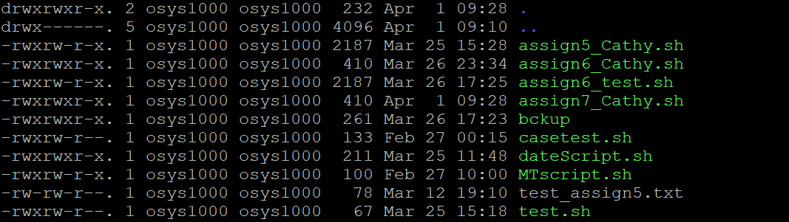

1. Test your script via PUTTY.

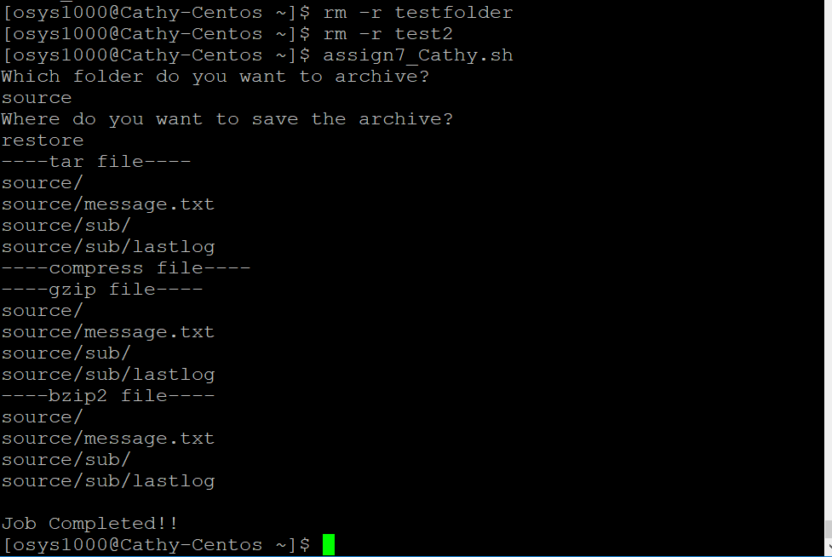

1. Post the Word document with your screenshots to the D2L Dropbox for the fourteenth in-class exercise in order to obtain credit for completing it.
2. That’s it.